- Microsoft Windows [Version 10.0.22631.3958]
(c) Microsoft Corporation. All rights reserved.

C:\Users\MASTER CORE>
C:\Users\MASTER CORE> cd : c\xampp\mysql\bin\
The filename, directory name, or volume label syntax is incorrect.

C:\Users\MASTER CORE>mysql -u root
'mysql' is not recognized as an internal or external command,
operable program or batch file.

C:\Users\MASTER CORE> cd c:\xampp\mysql\bin\

c:\xampp\mysql\bin>mysql.exe -u root
Welcome to the MariaDB monitor. Commands end with ; or \g.
Your MariaDB connection id is 8
Server version: 10.4.32-MariaDB mariadb.org binary distribution

Copyright (c) 2000, 2018, Oracle, MariaDB Corporation Ab and others.

Type 'help;' or '\h' for help. Type '\c' to clear the current input statement.

MariaDB [(none)]>\

- Create data Mahasiswa
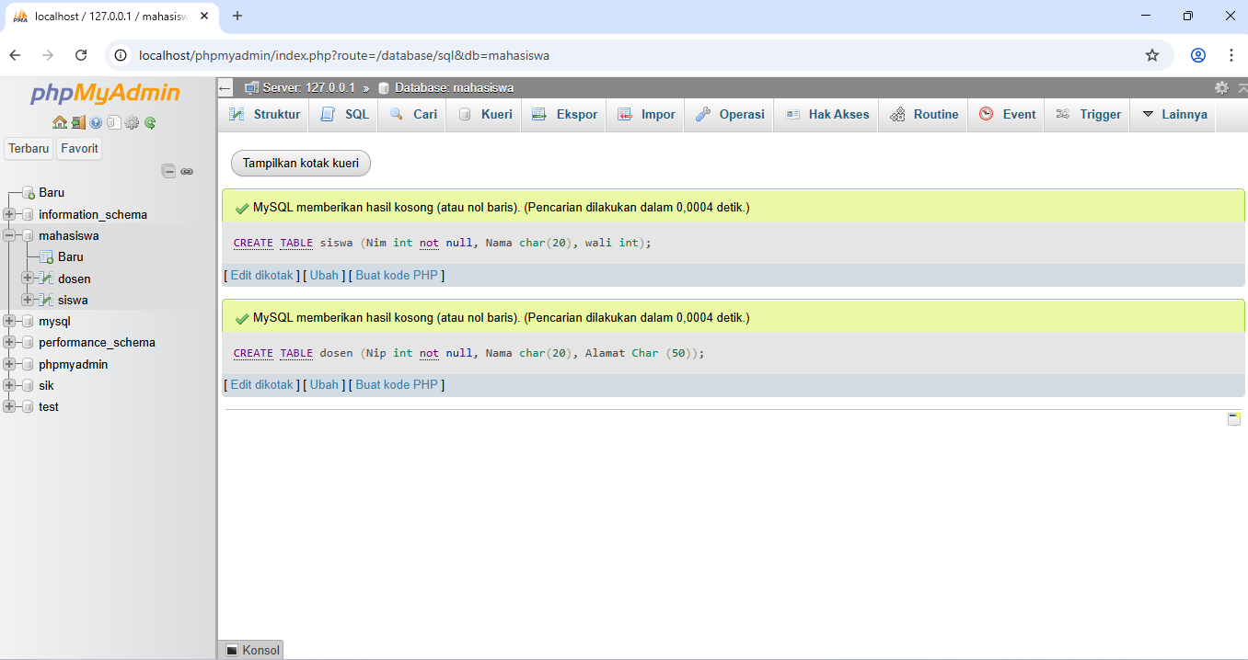

Tabel Dosen
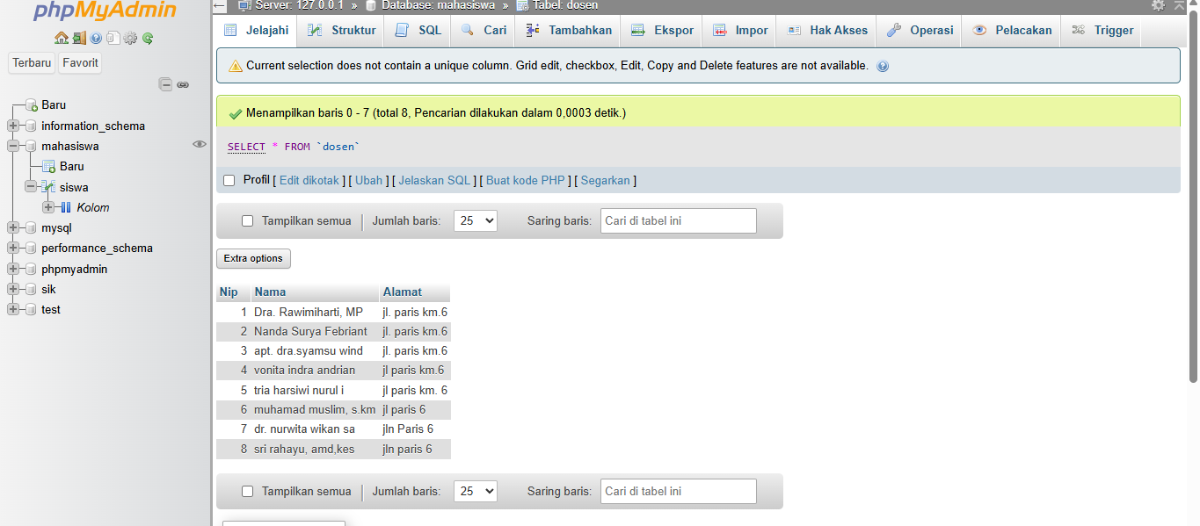
- SELE

